Logging into RStudio (in the BioSense Platform)

In order to directly process your BioSense data (within the BioSense Platform) using R, you must work through the RStudio application which is an analytic tool available within the BioSense Platform.

Go to <https://adm.biosen.se/rstudio/auth-sign-in> and login.

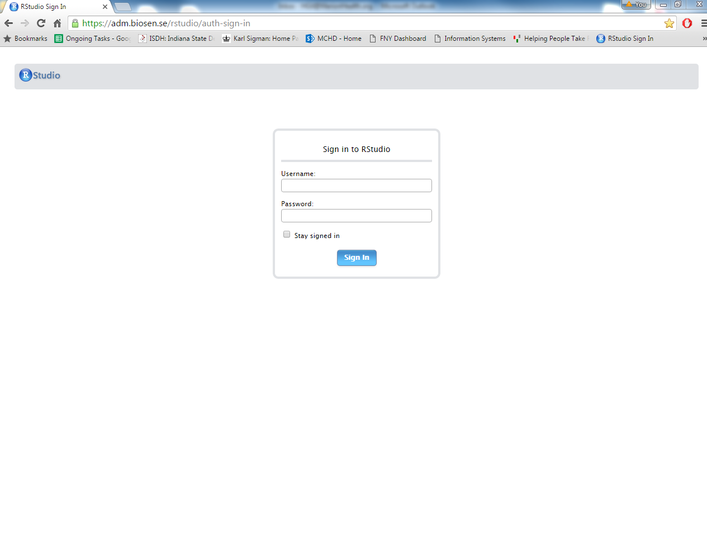

Once you login, you have the option of exporting your created datasets to work with them locally on any analytic program you choose (SAS, R, etc.).

Obtaining access to RStudio

Go to <http://support.syndromicsurveillance.org>, create an account, and login.

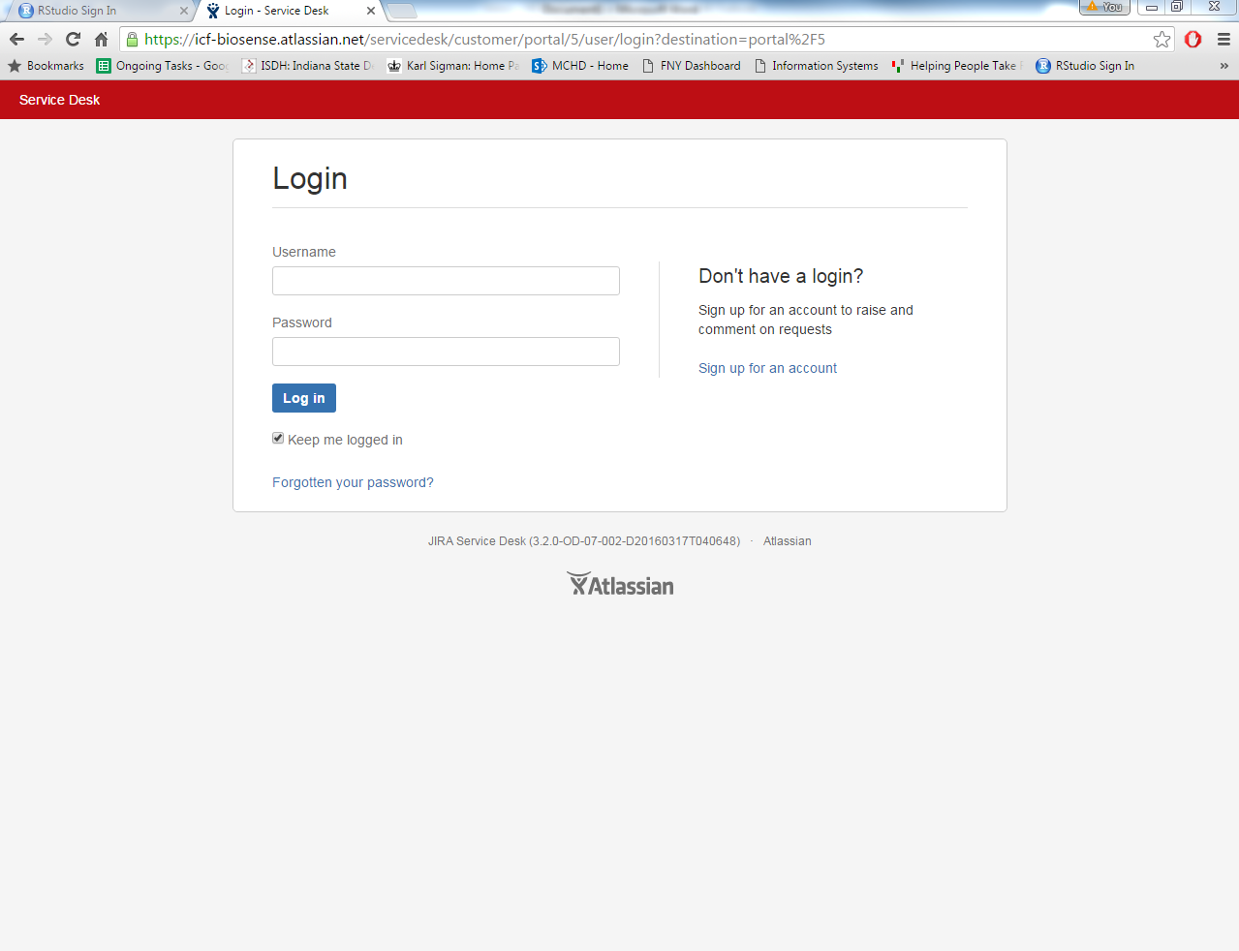

Click on the *Accounts* tab, then click on *User Account Access Request*.

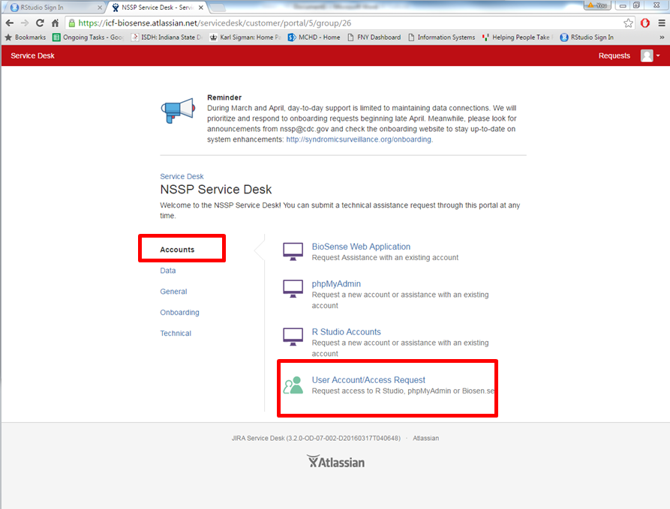

Fill the required information (example below)

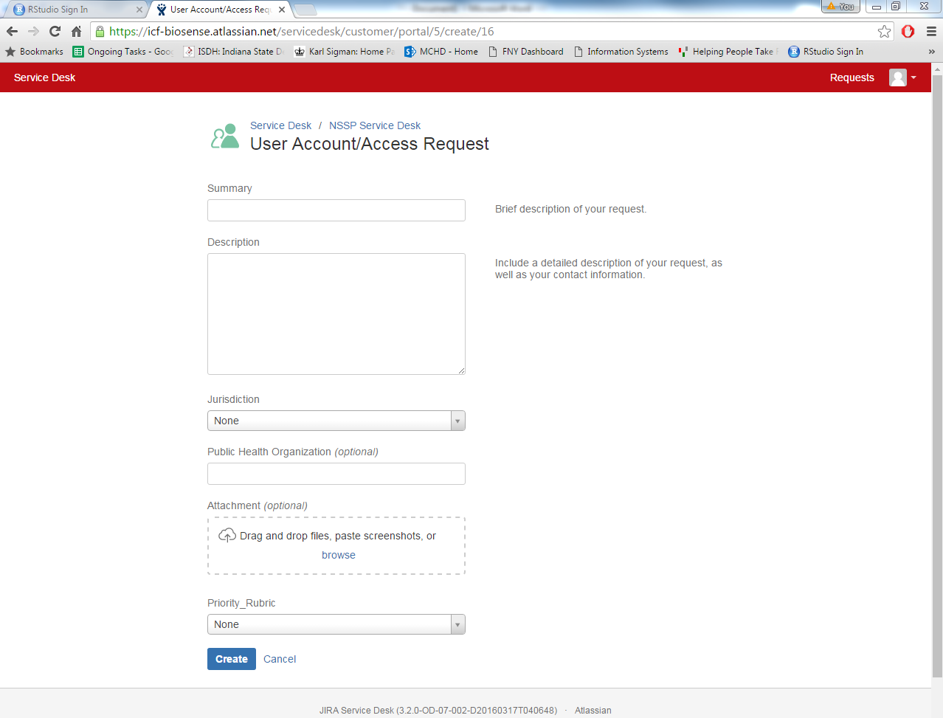

**Example**

Summary: Request RStudio login credentials.

Description: I would like to request login credentials to use the BioSense Platform’s RStudio application.

Priority_Rubric: Community Support